Easy Read Survey

Parent Survey
How well are social services supporting disabled children?

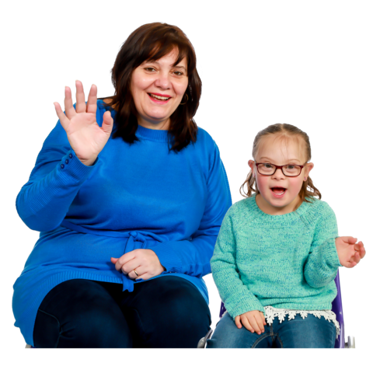

This document was written by Care Inspectorate Wales. It is an easy read version of their document ‘Parent Survey’.

About this survey

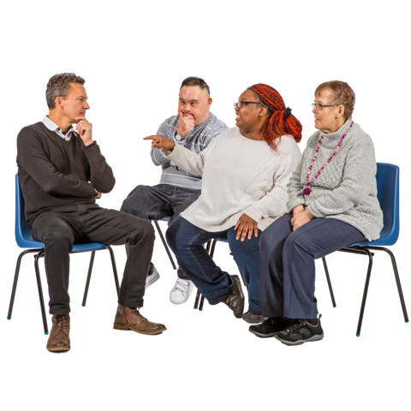
We are Care Inspectorate Wales.

We are checking how social services across Wales are supporting disabled children.

We want to know what parents of disabled children think.

What parents think is a very important part of our work.

This survey should take 5 to 10 minutes to complete.

You may need support to read and understand this document. Ask someone you know to help you.

Words in bold blue writing may be hard to understand. They have been explained in a blue box. And you can check what they mean page 18.

We do not need to know your name. We will only ask where you live in Wales. This is so we know which services you are talking about.

Once we have checked social services we will write reports about what we have found out. You can read these at: https://careinspectorate.wales

If you have any questions about this survey please email us at: CIWLocalAuthority@gov.wales or ring us on 0300 7900 126.

Thank you for your time.

Having your views heard

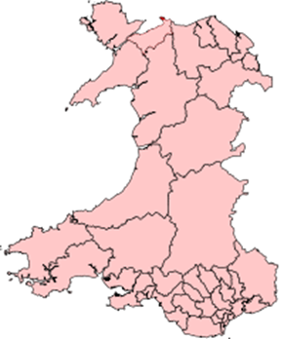 | - Where in Wales do you live?

Blaenau Gwent | ☐ | Merthyr Tydfil | ☐
Bridgend | ☐ | Monmouthshire | ☐
Caerphilly | ☐ | Neath Port Talbot | ☐
Cardiff | ☐ | Newport | ☐
Carmarthenshire | ☐ | Pembrokeshire | ☐
Ceredigion | ☐ | Powys | ☐
Conwy | ☐ | Rhondda Cynon Taf | ☐
Denbighshire | ☐ | Swansea | ☐
Flintshire | ☐ | Torfaen | ☐
Gwynedd | ☐ | Vale of Glamorgan | ☐
Isle of Anglesey | ☐ | Wrexham | ☐

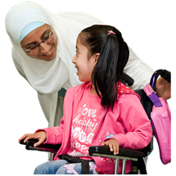 | - Do you care for a disabled child under the age of 18?
 |  | Yes | ☐
 |  | No | ☐

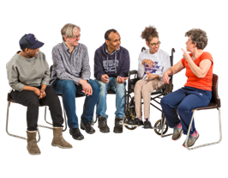 | - Has your social services department asked you what you think about services for disabled children? And how they could be better?
 |  | Yes | ☐
 |  | No | ☐

- Do you think that what parents think makes any difference to services for disabled children?

No, not at all | Not really | I do not know | Yes, a bit | Yes, a lot
☐ | ☐ | ☐ | ☐ | ☐

- Have you ever been offered a carer’s assessment?
A carer’s assessment is when social services ask your views about your care responsibilities and what is important for you.
 |  | Yes | ☐
 |  | No | ☐

 | - Do you have other children under 18 years old?
 |  | Yes | ☐
 |  | No | ☐

- Do you think it would help your other children to have extra support?

No, not at all | Not really | I do not know | Yes, a bit | Yes, a lot
☐ | ☐ | ☐ | ☐ | ☐

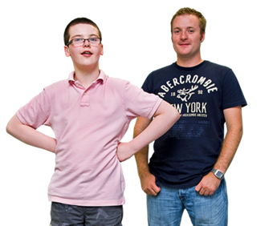 | - Does your disabled child have a social worker or other worker from social services?
 |  | Yes | ☐
 |  | No | ☐

- How well has the social worker got to know your child?

Not at all | Not very well | Well | Very well
☐ | ☐ | ☐ | ☐

- How well has the social worker learned to communicate with your child?

Not at all | Not very well | Well | Very well
☐ | ☐ | ☐ | ☐

- If you have anything else to say about your disabled child’s social worker please tell us in the box:

Getting help and support

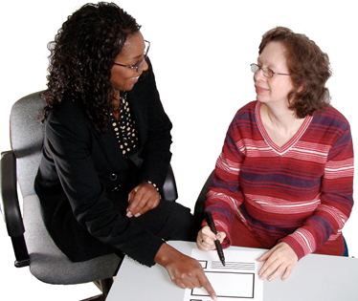 | - In the last year, have you asked social services for any help?  This also includes if somebody asked social services for you.
 |  | Yes | ☐
 |  | No | ☐

- When you asked for help from social services, how helpful were they?

Not at all helpful | Only a bit helpful | Helpful | Very helpful
☐ | ☐ | ☐ | ☐

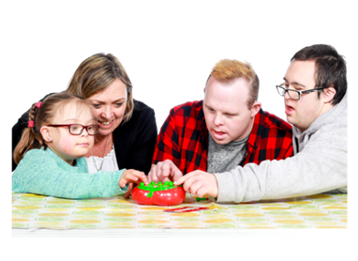 | - In the last year, have you told social services that you need support with looking after your disabled child?
 |  | Yes | ☐
 |  | No | ☐

- How helpful did you find these support services?

Not at all helpful | Only a bit helpful | Very helpful | I did not use the services | I was not offered any services
☐ | ☐ | ☐ | ☐ | ☐

- In the last year, has your disabled child been assessed by social services?
An assessment is a way of finding out if someone needs help and support.

 |  | Yes | ☐
 |  | No | ☐

- When your disabled child was being assessed, did you feel like you were being included and listened to?

I did not feel included at all | I did not feel very included | I do not know | Yes, I felt quite included | Yes, I felt very included
☐ | ☐ | ☐ | ☐ | ☐

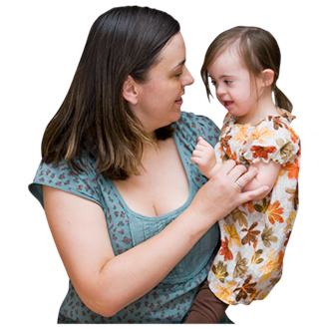 | - Is your disabled child under 5 years old?
 |  | Yes | ☐
 |  | No | ☐

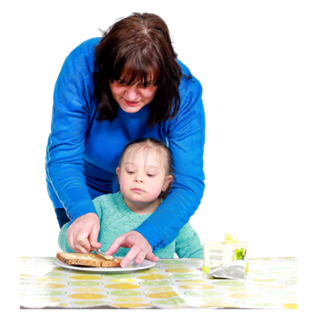 | - Is there enough childcare in your area for your disabled child?  This includes things like:  - Nurseries  - Playgroups  - Childminders

There is not enough childcare in my area | I do not know | There is enough childcare but not a lot of choice | Yes, there is a lot of different childcare
☐ | ☐ | ☐ | ☐

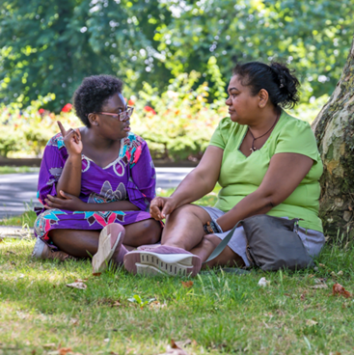 | - Have you asked social services for help so you can take time off from caring for your disabled child? This could be things like:  - Short breaks away from home  - Babysitting services  - Child minding.
 |  | Yes | ☐
 |  | No | ☐

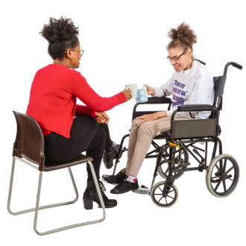 | - Did you get support so that you could have a break?
 |  | Yes | ☐
 |  | No | ☐

- If you have anything else to say about getting support to take a break please tell us in the box:

Working together

People from social services, schools, hospitals and other public groups need to work together to help support disabled children. We will call these people professionals.

- How well have professionals worked together to help your child get the best education?

Not well at all | Not very well | This question does not apply to me | Well | Very well
☐ | ☐ | ☐ | ☐ | ☐

- How well have professionals worked together to plan changes for your child? Changes could include:
- Changing schools
- Moving into supported living
- Living independently

Not well at all | Not very well | This question does not apply to me | Well | Very well
☐ | ☐ | ☐ | ☐ | ☐

- If you have anything else to say about professionals working together please tell us in the box:

Well-being

- Are there enough activities in your area for your disabled child to have fun and make friends?

There are no or hardly any activities | There are not many activities | I do not know | There are enough activities but not much choice | Yes, there are lots of activities
☐ | ☐ | ☐ | ☐ | ☐

- Do you feel like you have support to help your disabled child be more independent?

I have no or hardly any support | No, I do not have much support | I do not know | Yes, I have some support | Yes, I have lots of support
☐ | ☐ | ☐ | ☐ | ☐

- If you have anything else you would like to say about your experiences please tell us in the box:

Thank you for your views.

Hard Words

Assessment
An assessment is a way of finding out if someone needs help and support.

Carer’s assessment
A carer’s assessment is when social services ask your views about your care responsibilities and what is important for you.

Professionals
Professionals are people who work in certain jobs. Like social services, schools and hospitals.

